**Assignment 5 By Lavin Choudhary**

**Q1:-** Set up a domain, setup a server on a VM and use the DNS server for traffic

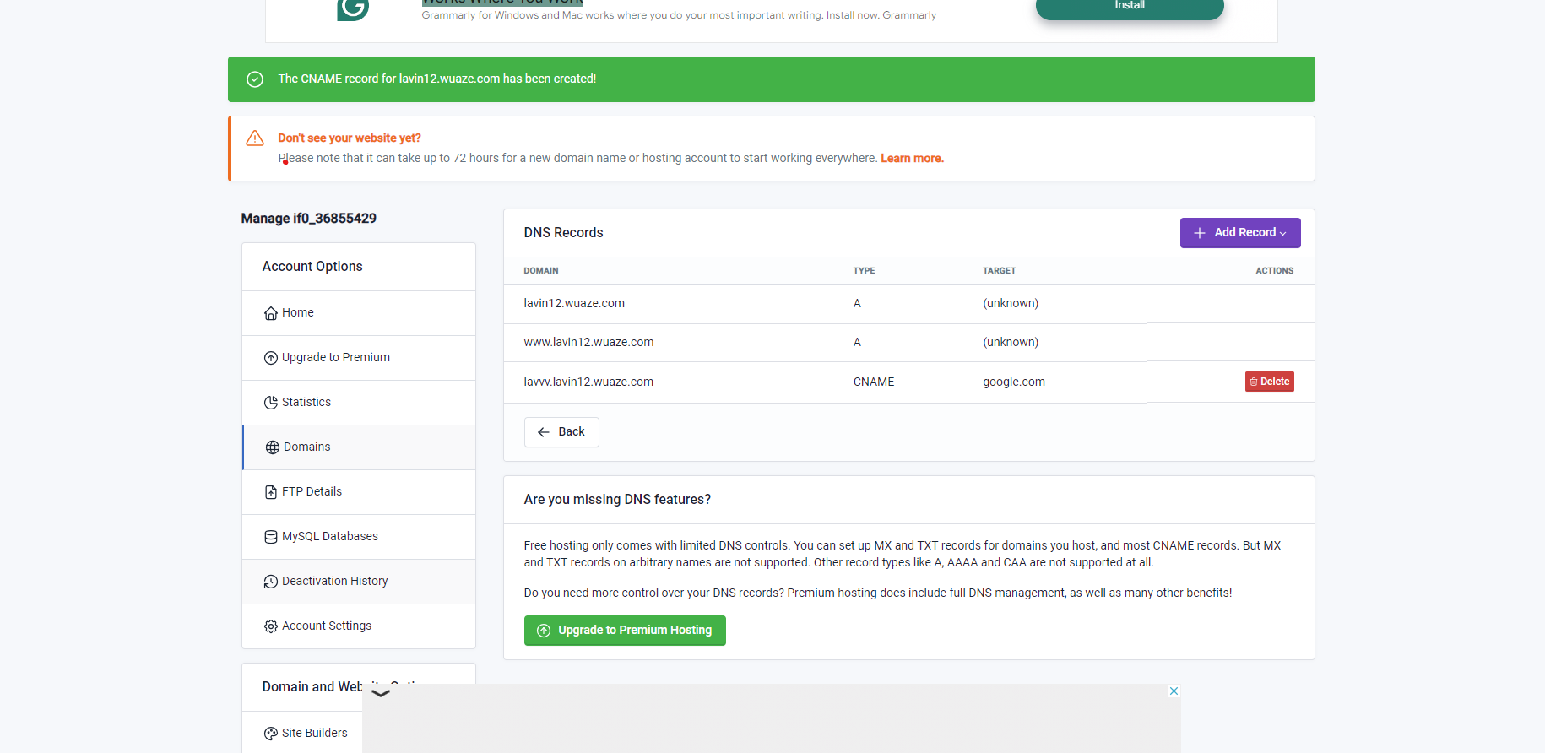

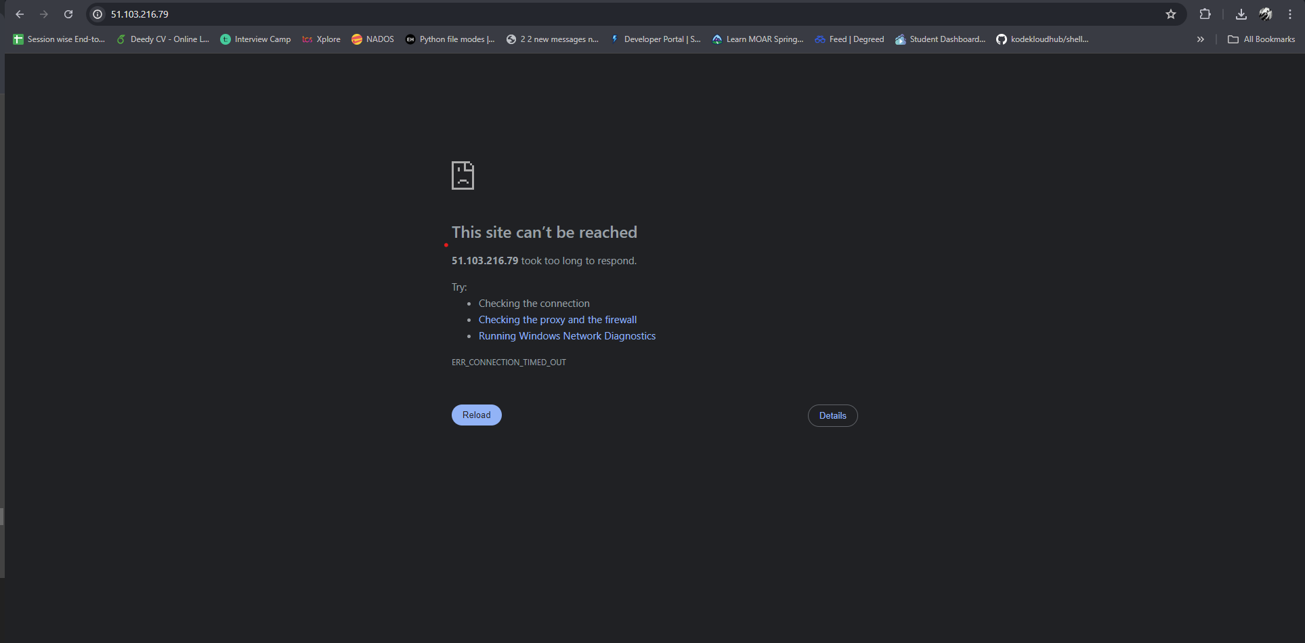

**Q2:-** Create and test Azure Application gateway.

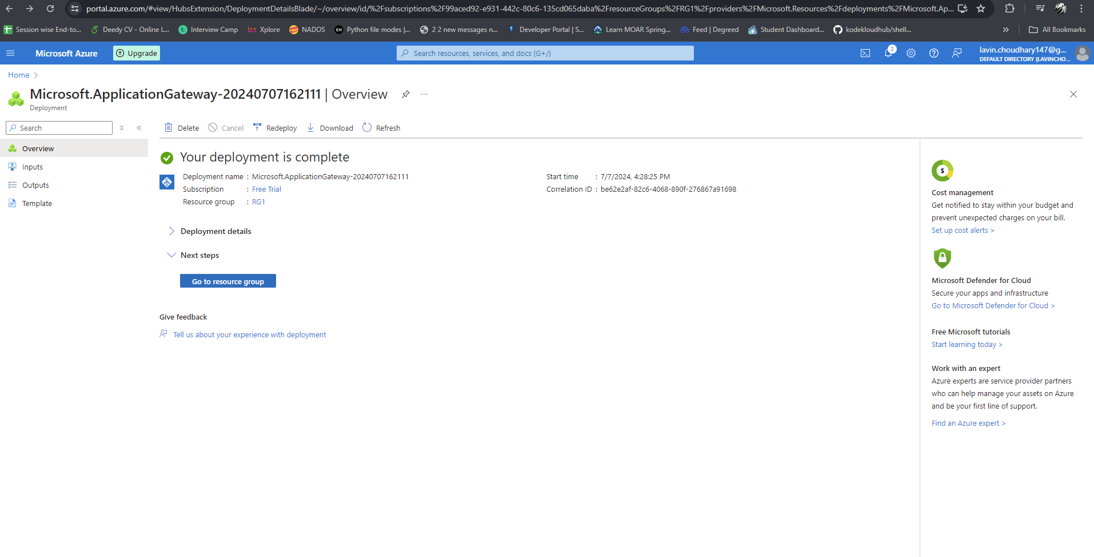

**Q3:-** THIS SI THE DESCRIPTN OF THE ROW 23.

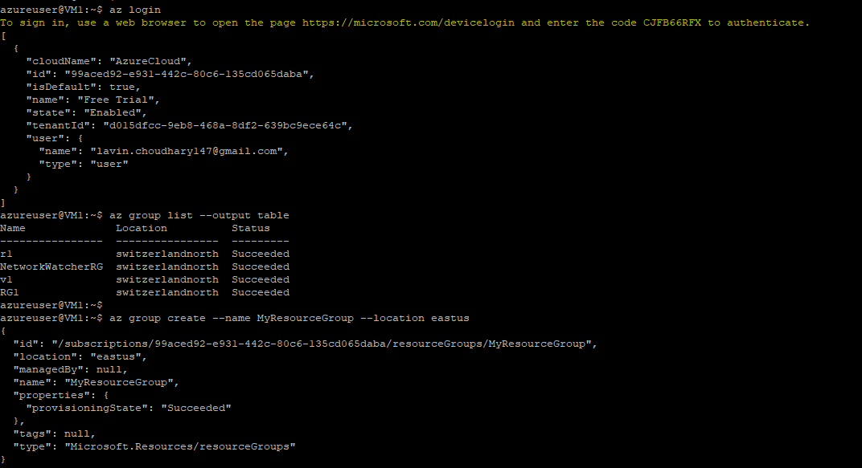

**Here is the resources which I have used during this whole assignment in Azure.**

